Prolog Lecture One:

**Installation**

Step 1 : Install SWI-Prolog

You will find one downloaded in your course folder. Or Download the latest one for windows/linux from SWI-site

Step 2: Install Java and Eclipse

Step 3 : Install pdt [http://sewiki.iai.uni-bonn.de/research/pdt/docs/start]

Go to Eclipse>Help>Install new Software > Add …

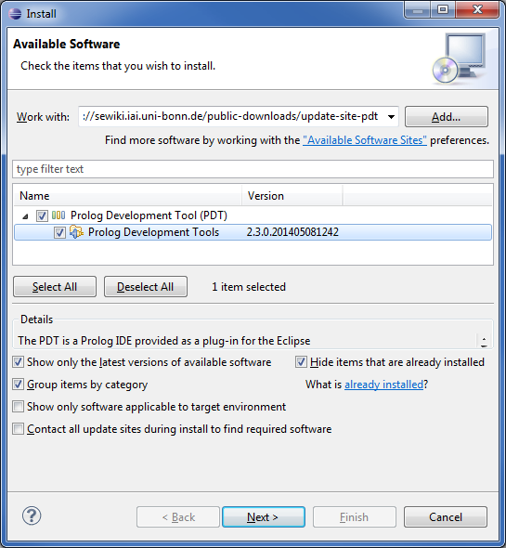

In the add dialog use <http://sewiki.iai.uni-bonn.de/public-downloads/update-site-pdt/>

Press “Next” and follow the instructions.

**Quick Start**

**First check the SWI-Prolog configuration with Eclipse > Window Preference**

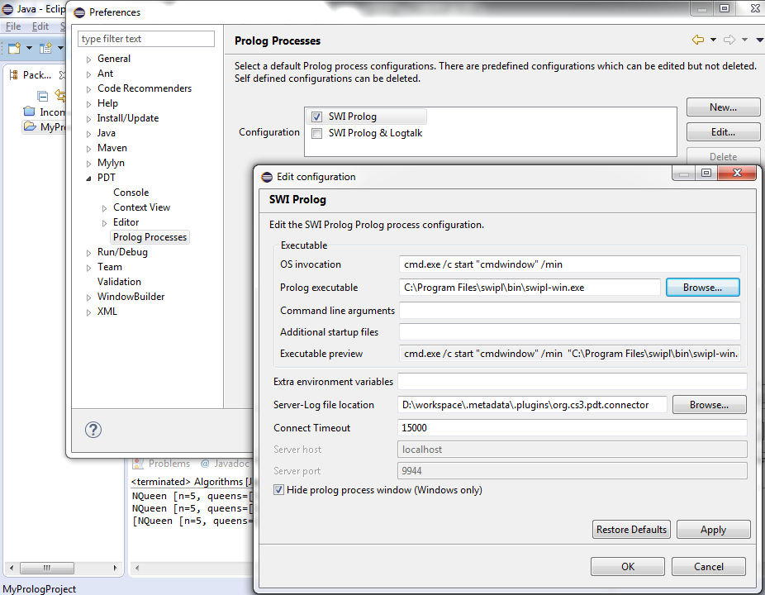

**Create a new Project in Eclipse**

**New > Project > General > Project**

**Now add a new prolog module**

**New > Other > PDT > Prolog Module**

**Now change your perspective to prolog.**

**You are all set to start Prolog!!**